CSE 581

**Lab 15: Triggers**

1. when inserting a new record, update the Courses table’s OpenSeats for the course into which the student is being enrolled.

if(OBJECT_ID ('UpdateOpenSeats','tr')is not null)

drop trigger UpdateOpenSeats

go

CREATE TRIGGER UpdateOpenSeats

ON CourseEnrollment FOR INSERT

AS

DECLARE @CourseId AS INT

SELECT @CourseId = CourseId FROM inserted

UPDATE Courses

set Courses.OpenSeats = Courses.OpenSeats - 1

where Courses.CourseId = @CourseId

AND Courses.OpenSeats >= 1

GO

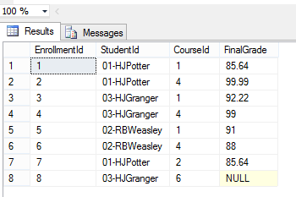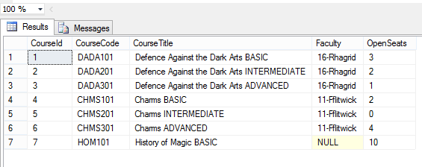

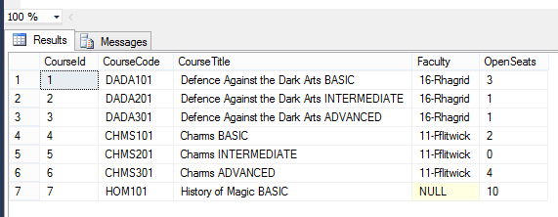

2.when deleting a record, update the Courses table’s OpenSeats for the course from which the student was deleted.

if(OBJECT_ID ('UpdateOpenSeats2','tr')is not null)

drop trigger UpdateOpenSeats2

go

CREATE TRIGGER UpdateOpenSeats2

ON CourseEnrollment FOR DELETE

AS

DECLARE @CourseId AS INT

SELECT @CourseId = CourseId FROM deleted

UPDATE Courses

set Courses.OpenSeats = Courses.OpenSeats + 1

where Courses.CourseId = @CourseId

GO

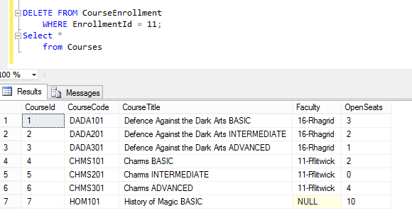

3.if an update happened on the CourseId (student switched courses), adjust the Courses table’s OpenSeats accordingly.

if(OBJECT_ID ('UpdateOpenSeats3','tr')is not null)

drop trigger UpdateOpenSeats3

go

CREATE TRIGGER UpdateOpenSeats3

ON CourseEnrollment FOR UPDATE

AS

DECLARE @oldCourseId AS INT

DECLARE @newCourseId AS INT

SELECT @oldCourseId = CourseId FROM deleted

SELECT @newCourseId = CourseId FROM inserted

UPDATE Courses

set Courses.OpenSeats = Courses.OpenSeats + 1

where Courses.CourseId = @oldCourseId

UPDATE Courses

set Courses.OpenSeats = Courses.OpenSeats - 1

where Courses.CourseId = @newCourseId

AND Courses.OpenSeats >= 1

GO

